# Algorithm for file updates in Python

## Project description

As a security professional at a healthcare company, my task is to create a Python algorithm that compares the IP addresses in an allow list, which identifies employees permitted to access restricted patient records, against a remove list, and updates the allow list file by removing any IP addresses that are also found on the remove list to maintain secure access control.

## Open the file that contains the allow list

* My first step was to store the text file "allow_list.txt" and the list to be removed as variables called import_file and remove_list respectively. This makes it easy to use this data later in the rest of the script
* The next step was to use the open() with the "r" parameter to signify the action we take with the file

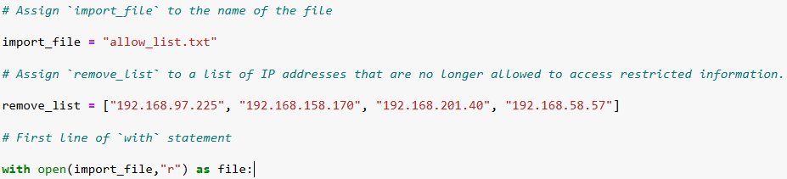

## Read the file contents

In order to use the open function we need to use the .read() method to read the imported file and then we stored it in a variable named ip_addresses and displayed the results as a usable string.

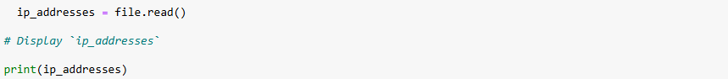

## Convert the string into a list

To convert the string to a list we use the .split() method. Afterwards we displayed the new list

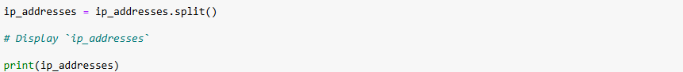

## Iterate through the remove list

We then use the for loop to display all the individual element the list we created called ip_addresses

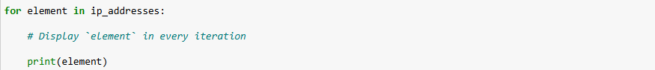

## Remove IP addresses that are on the remove list

We then use the if in and .remove() statements within the for loop to search through the list for any IP addresses that are in the remove_list variable.

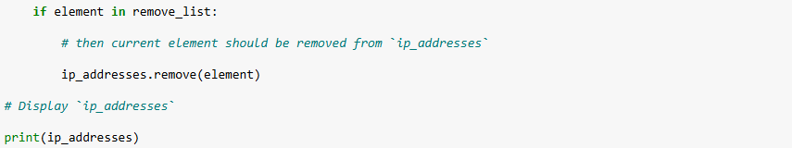

## Update the file with the revised list of IP addresses

* To store the new modified last back into the .txt file the IP address variable needs to be changed from a list back into a string and we did that using the .join() method
* After this we were able to use the with function with the open() to access the file using "w" parameter and .write() method to write the new details to the file

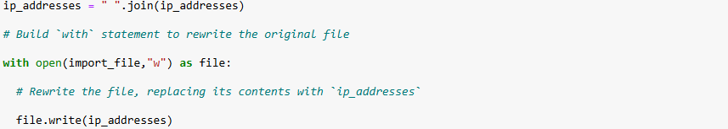

## Summary

This script allows me to remove specific items from a .txt file and allows me to practice using various functions for writing and reading text information using python. I was also able to turn this code into a function that allows me to use it easily for other projects.

